## Laboratory 2: Oscilloscope

1. **Introduction**

**1.1 Goals**

* Investigate the propagation delay of logic gates by using Oscilloscope.
* Know and design edge detector circuit.

## Requirements

* Read 74LS74’s and prepare for clock divide circuit design.
* Research about edge detector circuit design methods.
* Read the **Huong dan Oscilloscope.pdf** file which introduces the Oscilloscope basics.
* Follow the link at [https://www.youtube.com/watch?v=gIfH_80S2uA&t=0s](https://www.youtube.com/watch?v=gIfH_80S2uA&amp;t=0s) which demon- strates the operation of Oscilloscope.

## 1.3 Report Requirements *

For each exercise:

* Include your connection diagram (with Oscilloscope)
* One or two picture of your circuit on DS KIT and results on Oscilloscope.

# Contents

## What is Oscilloscope?

An oscilloscope is an instrument used to measure almost any electrical signal on a two-dimensional graphing display (there are also three-dimensional graphing displays available). In general, oscil- loscopes are used to study the characteristics of voltage versus time; displayed on the vertical and horizontal axis respectively. This general-purpose display presents far more information than is available from other test equipment such as frequency counters or multimeters. Oscilloscopes can help detect the DC and AC components of a signal, the noise level accompanying the signal, and whether the noise is varying with time. It also gives a visual representation of the frequency - number of cycles per second - being fed into the oscilloscope. The best feature of the oscilloscope is that all of the above functions are displayed at the same time, thus, eliminating the necessity of doing separate time consuming tests.

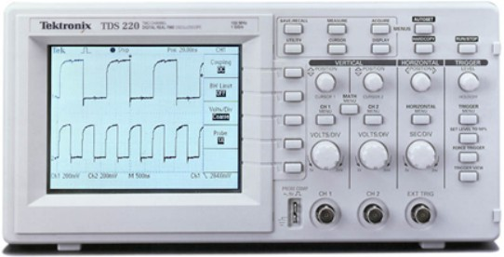

## Types of Oscilloscope

Generally, oscilloscopes can be divided into two categories - analog and digital. Analog scopes are the more conventional and bulkier units that use cathode ray tubes to display waveforms. When the signal frequency exceeds CRT’s writing speed, the display becomes too dim to see. The fastest analog scopes can display frequencies up to about 1 GHz.

Digital scopes are more compact and lightweight using liquid crystal displays. In contrast to Analog scopes, a digitizing oscilloscope uses an analog-to-digital converter (ADC) to convert the voltage being measured into digital information. The digitizing scope acquires the waveform as a series of samples. It stores these samples until it accumulates enough samples to describe a waveform, and then re-assembles the waveform for viewing on the screen. Because the waveform information is in digital form (a series of stored binary values), it can be analyzed, archived, printed, and otherwise processed, within the scope itself or by an external computer.

## How Digital Storage Oscilloscopes work

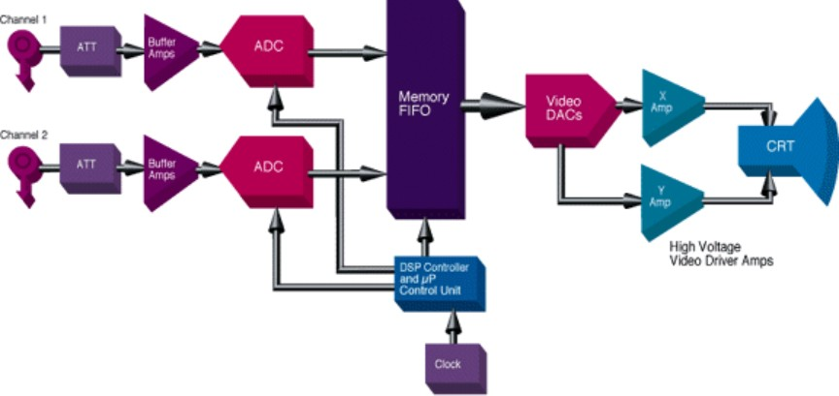

This signal chain shows a typical implementation of a digital storage oscilloscope.

The input signals from the oscilloscope probes are usually attenuated and then buffered before being fed into an ADC(Analog to Digital converter). The attenuation is provided by a passive resistor network. The buffer amplifiers perform level shifting to match the input of the ADC. Once the signals have been digitized, the digital data is then fed into a FIFO (First-In First-Out) memory. The timing control between the ADC and the FIFO memory is usually performed by a DSP (Digital Signal Processor) and/or a µProcessor.

The digital data is fed from the FIFO memory into a high speed video DAC (Digital to Analog converter) which converts the digital data stored in memory back into analog format. Once the data has been converted back into analog format, it is then fed into the high voltage X and Y video driver amplifiers that directly drive the CRT display.

## Getting started

Before you start working with your oscilloscope, there are a few things you need to do to ensure that your tests will be successful.

### Functional check

Before you start working with your oscilloscope, there are a few things you need to do to ensure that your tests will be successful.

* + - 1. Turn on the oscilloscope and wait till you see ”PASSED” on the screen. This means all self-tests have passed successfully.

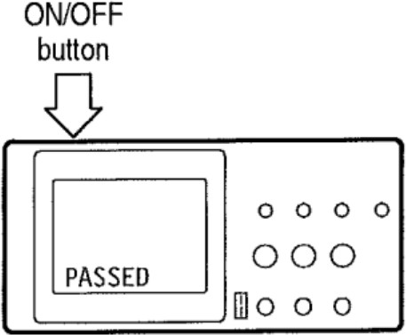

* + - 1. Connect one of the oscilloscope probes to channel 1. Attach the probe tip and reference lead to the PROBE COMP connectors.

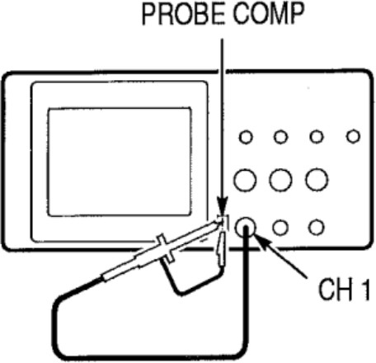

* + - 1. Push the AUTOSET button. The display will show a squarewave
      2. Repeat steps 2 and 3 for channel 2

### Display

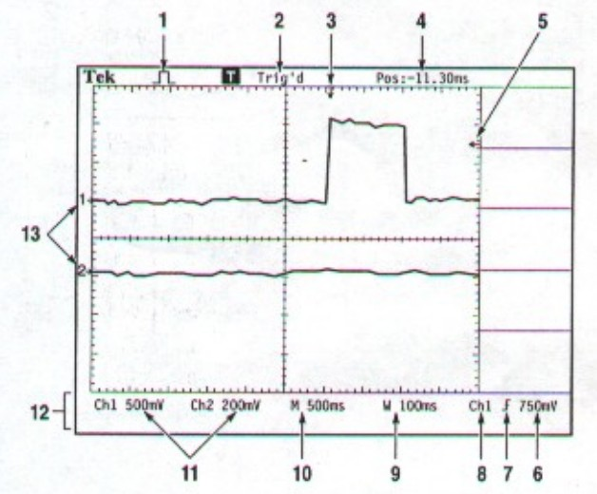

1. This Icon shows the acquisition mode (Sample mode, peak detect mode and average mode).

2. Trigger status lets you know if there is a trigger source or if the acquisition has been stopped.

3. Horizontal trigger position.

4. Difference (in time) between center graticule and trigger position.

5. Trigger level marker.

6. Numeric value of trigger level.

7. Trigger slope (+ve edge trigger or -ve edge trigger).

8. Trigger source used (CH1 or CH2).

9. This readout shows the timebase setting in the window zone.

10. Main timebase setting.

11. Shows channels 1 and 2 vertical scale factors.

12. Display area for momentary on-line messages.

13. Ground reference points of displayed waveforms.

### Horizontal control

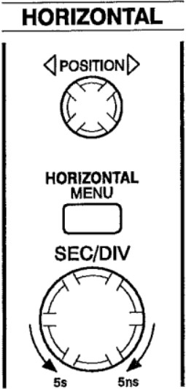

* POSITION: Adjust tho horizontal position of all channel.
* SEC/DIV: Select tho horizontal time/div (scale factor) for the main timebase and the Window Zone.

### Vertical control

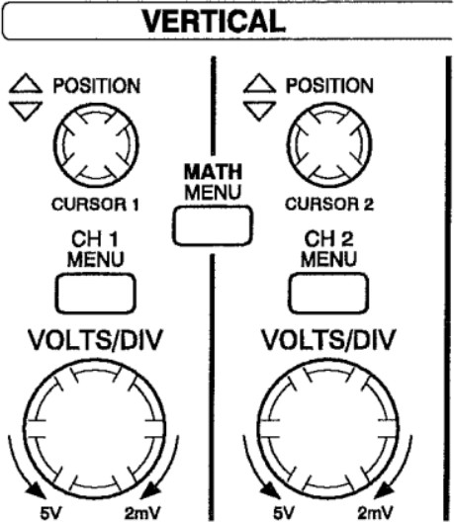

* POSITION: Vertical adjusts the channel 1 or 2.
* VOLTS/DIV: Selects calibrated scale factors.

### Analyze signal with cursor mode

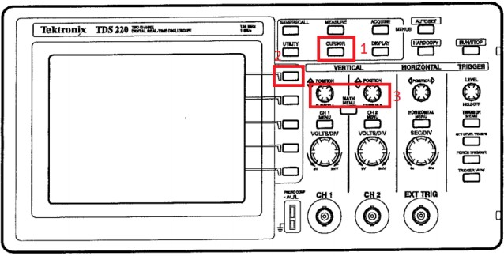

* + - 1. Press Cursor for setting cursor mode.
      2. Press the first functional button, select Time type.

3. Use POSITION to adjust the cursor’s position.

# Exercises

**Exercice 1**: Measurement Propagation Delay

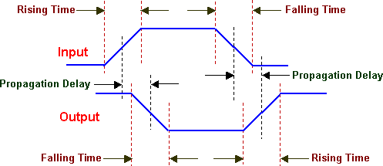

Figure 1: Propagation Delay

Use oscilloscope for measure propagation delay of these following ICs and fill these gaps below:

7400: .....

7404: .....

7408: .....

7432: .....

**Exercice 2**: Egde Detector Circuit

Implement 1 on 3 circuits below and test it by using oscilloscope:

1. Use IC 7404 and 7408 to implement edge detector circuit.

1. Use IC 7404 and 7432 to implement edge detector circuit.

3. Use only IC 7400 to implement edge detector circuit. (+1 bonus)

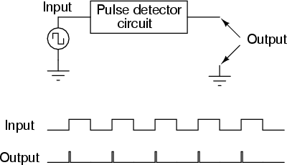

Figure 2: How edge detector circuit works

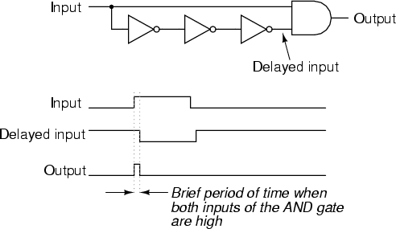

Figure 3: Sample edge detector circuit design

**Exercice 3**: (Extend Exercises) Implement the circuit below using edge detector circuit in Ex2.

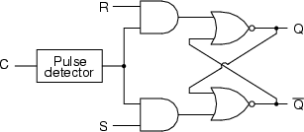

Figure 4: SR-Latch Design

Then, fill the truth table below.

|  |  |  |  |  |
| --- | --- | --- | --- | --- |
| **C** | **S** | **R** | **Q** | *¬***Q** |
|  | 0 | 0 |  |  |
|  | 0 | 1 |  |  |
|  | 1 | 0 |  |  |
|  | 1 | 1 |  |  |
| X | 0 | 0 |  |  |
| X | 0 | 1 |  |  |
| X | 1 | 0 |  |  |
| X | 1 | 1 |  |  |

Table 1: SR-Latch Truth Table

Test circuit using Oscilloscope (Channel 1 for C signal, Channel 2 for Q signal) and describe the function of this circuit